**CE101 Team Report Assignment**

**Group: Group B16**

**Team Leader:** *Mohamad Mounzer*

**Project Manager:** *Cieran Almond*

**Team Specialists:** Rukayat oyeleke, Alexandros Orphanides, Manik Anadkat.

Table of Contents

Chapter 1 The Executive Summary (422 words) 3

Chapter 2 Team Working (1436 words) 3-6

2.I An introduction to Team Working 3-4

2.II Team Activity Report 4-6

2.II.a The team effort summary table 34

2.II.b Detailed report of each team members contribution to the project 4-6

Chapter 3 Product Development (5472 words) 7-23

3.I An introduction to Product Development 7-11

3.II The Team Product 12-18

3.II.a The product specification 12-15

3.II.b The product design 15-16

3.II.c The product implementation 16-17

3.II.d The product testing 17-18

3.III Context 18-23

3.III.a Legal matters 18-20

3.III.b Ethical matters 20-22

3.III.c Sustainability 22-23

3.III.d Health & safety matters 22-23

Chapter 4: Project Management (2140 words) 23-28

4.I An introduction to Project Management 23-26

4.II Project Management Report 26-27

4.II.a A description of the Gantt chart 36

4.II.b An evaluation of the project management 27-28

Chapter 5: Conclusions (488 words) 29-30

Appendix 32-35

A. Python Code 32-33

B Team effort summary table 34

C Project management Gantt chart 35-36

# Bibliography……………………………………………………………………………………37

# Chapter 1 The Executive Summary (422 words) (Mohamad Mounzer)

The Team mission is to allow users of the Nao robot of young age to be able to get some knowledge of how to make basic mathematical calculations.

Report content:

This report will emphasise how the team work has been done over the past months with effectively using the specified lab sessions for the CE101 module. In those lab sessions, a various tasks has been set from the team leader and the project manager for the team to work on such as: the product specifications, the product development, the programming of the Nao robot using python codes and Choregraphe for implementation. The team was divided when first got introduced to the team in the first lab the team had; into a team leader, project manager, and four specialists. Team leader is Mohamad Mounzer, project manager is Cieran Almond, and the four team specialists are Rukayat oyeleke, Alex Orphanides, Manik Anadkat. After agreeing to everyone’s role in the team, each member had his main focus and target to of coming out with the best programmed robot. Doing so has set the team with enthusiasm of taking part in every task set by the team leader and manager and to be up to date with the completion of the tasks on time so the project deadline can be met on time.

The team decided to make something beneficial and unique where the end user can benefit from using the robot. The program to work on has to allow the robot to be educational and fun to use. The idea that the team came up to is to make a program using python scripts and Choregraph that allows the Nao robot to be able to act as a mathematics teacher, and at some point the robot will be dancing specific type of dance when the user get answers right when the robot test the user knowledge; where the user (children) has 3 options to choose from when the robot states them. The robot will be able to specify the option chosen by the user using speech recognition which is to be done in the choregraph programming software. On the other side, before the team has started to work on programming the robot and getting ideas of what to include in the robot functions, ethical and legal matters has been researched by the team leader and the team manager to make sure that the product can be free from copy rights concerns so that the product idea will be unique and not copied from another product.

# 

# Chapter 2 Team Working (1436 words) (Mohamad Mounzer)

## 2.I An introduction to Team Working

Briefly stating what team working is; team work is where there is different team members that have a mutual goal and tasks to be met and completed. A team is formed of a team leader, team manager, and other team members in our case those team members are the team specialists. The team structure of B16 is as stated above it has the team leader, manager and team specialists. All team members have contributed in tasks that has been set to meet the product development and the completion of the tasks. Leadership is an essential part of the team work as this status help the team gather their ideas and set them to one critical goal to be mutual for all team members. The leader doesn’t have to be a dictator as this might arouse issues inside the team between team members because being a dictator team leader will mean that the members’ opinions are not listened to and not bring benefit to the product development, so therefore, the leader must be democratic and can listen to all the opinions of the team members as this will bring different topics which might help the product development. A good team leader will be able to manage the tasks for each team member, will also be able to keep the team on track and not waste team time, keep team members motivated by setting progress sheet to allow the team members monitor their progress to task completion and to advice the members of how to meet deadlines of the set tasks.

The other essential team position is the team manager, the team manager is another type of a leader but a leader of group of team members, the team manager has specific duties in the team which allow the management of tasks set to members by team leader and team manager such as taking attendance of meetings set in the team, taking down agendas, and other duties to be done only by the team manager.

## 2.II Team Activity Report

### 2.II.a The team effort summary table

This is written in Appendix B

### 2.II.b Detailed report of each team members contribution to the project

**Mohamad Mounzer:**

As a team leader, I had to attend most of the lab sessions to monitor the team progress and check if every task set has been up to date and met by the deadline. On the other hand, being a leader is not an easy position as this bring to the leader a lot of stress as most of the work set to the team members must be monitored and checked by the leader to make sure that they meet the team project requirements. Being an autocratic leader will bring so much problems to the team work as autocratic leaders does not tend to listen and take into consideration other team members opinions; therefore, the best option was to be a democratic, friendly leader to be able to take all team members’ opinion and ideas into consideration as this brings more ideas to the project that might be helpful in the implementation of the program. My role as team leader has helped me to gain experience on how to make the team members on track and not full behind on the completion of the project which helped the team be successful at the end of the day and came out with an outstanding result whereas the robot’s program didn’t work as it should work this was due to lack intensive sessions of testing but the team overall was happy with the final product developed.

**Rukayat Oyeleke:**

My role in my team was a team specialist/programmer. Initially I re-designed and edited the second draft of the core block diagram. I wrote sections of the team report and did some minor Choregraphe programming. This included the sections introducing and describing our product. The team leader allocated me the sections I worked on. I think I could have done more tasks in the project particularly on the team report.

I attempted to attend all the scheduled labs and meetings, with the exception of the few times I was ill at the end/beginning of the year. During the classes and meetings, I worked on the individual sections I was allocated in the report and program code.

**Alexandros Orphanides:**

Throughout the first term, I only missed one meeting, completed all the work related to my role as a specialist, and devoted a fair amount of time on product development. Furthermore, I spent a significant amount of time familiarising myself with the Choregraphe software, and began the process of developing robot behaviours, based on vague ideas of what the team wanted to do with the robot.

On the first team meeting after the break, I informed the team of incomplete team tasks from the first term. In addition, I had an active role in helping the team get back on track with the project, which was crucial to the formation of the final specification and definitive design idea. Besides that, I assisted the project manager in splitting up the core functions into smaller parts and creating a rough block diagram, that I later revised into a final. As a specialist, I was assigned a large portion of the core functions from the block diagram. I created a Choregraphe simulation that incorporated essential robot behaviours such as the introduction, speech recognition, and switch cases that were crucial for the control flow of the robot functions. Moreover, I developed python code for generating mathematical questions, using random integers. In week 19, I gave a presentation on my progress related to the implementation tasks as well as other tasks of the project, which I was working on.

Besides implementation work, I conducted research that was relevant to chapter 3 of the team report, and wrote a precis on product development, to serve the team as a helpful guideline. Additionally, I found useful resources relevant to the legal matters section of the report. I worked in close cooperation with the team leader to test and debug functions and behaviors, and combined the functions and behaviors from the team members, into a single Choregraphe simulation which I submitted via email to the supervisors before the demonstration. Lastly, I have written the product testing section of the team report and a part of the conclusions sections, which were assigned to me.

In conclusion, based on all the above I believe my contribution towards the project was plentiful. It is my position that I have fulfilled my role as a team specialist to a great extent, and always acted responsibly as a team member.

**Cieran Almond**:

My role for team B16 was the project manager; it was my job to organise team meetings, maintain a team logbook and create and update our projects Gantt chart along with general tasks of allocating jobs to team members and making sure specialists knew what they were doing. The team logbook was updated every week, including out of timetable meetings, the Gantt chart was changed to accommodate the less standard meetings. An area my project management skills were lacking was during the development phase of the project; we decided on an idea to complete, however I failed to allocate tasks to members beforehand to assess their knowledge of what they could achieve with the idea we had conceived. This lead to us solidifying an idea which we couldn’t build, leading to overall delays as we had to rethink the idea, salvaging pieces from the idea previous.

However, overall I feel the team members that were active in meetings had an understanding on what the project plan had set for them and their role in achieving their specific goals of the project.

**Manik Anadkat:**

My role in the team (B16) was the product development specialist; this role meant I was the core programmer for the project, focusing on chapter 3. It required me to work with my fellow team members in order to link up all of our parts to create the final project. I helped by creating the design idea of the product, this being a robot that helps teach simple maths by explaining it through objects if the user gets the answer incorrect. I also wanted to implement a testing element to the program, which would enhance user experience by asking the user questions that have previously been answered wrong. However, this highlighted an area which I could’ve improved (time management) upon as I spent a lot of time trying to get the testing function to work rather than focusing on the core functions.

# Chapter 3 Product Development (5472 words)

## 3.I An introduction to Product Development

What is product development, how do we develop a product and what methodologies are there?

Product development is the idea or practise of bringing a new original idea to the market or the modification of existing products in a rather significant way. Usually funded by a grant from a company, personal funding or more recently public funding in the form of kick-starters.

There are a multitude of different ways to develop a product, usually following a set of stages. A very general way of developing a product can go as follows:

Generate ideas.

Refine idea.

How you can use your personal skills to fit with your strategy.

Research for a gap in the market.

Research potential competition.

Form a methodically implemented team with different skillsets.

Budgeting, set objectives and deadlines.

Analysing potential risks.

Designing your idea.

Prototyping the idea into a product.

Finalise the prototype in preparation for launch.

Launching the product.

The example above is generally classed as a “development methodology”, though there are many ways to go about developing your product; it’s entirely up to the individual, however some methods are move proven and overall produce a better result than others. For example, the “Ad-hoc” method employs no plan, just create a product and fix issues on the way often leads to the production of poor quality products.

More methodologies and what they’re about:

1. Waterfall Model:

The waterfall model follows a very linear flow sequence in a certain order, only progressing onto the next stage of development if the previous stage is complete. A general sequence would look something like the following:

Requirements & analysis>Design>Implementation>Testing>Deployment of prototype to meet specification.

Pros of the waterfall system:  
1. Simple, easy to follow design for set in stone requirements.

2. Phases are processed and completed one at a time, allowing for easy organisation of the project since they don’t overlap.

3. Review process after each stage allows for delivery of a good quality product.

Cons of the waterfall system:  
1. The system only matches precise needs of the consumer which can change at any time, and the idea of knowing upfront requirements of design is often seen as an unrealistic expectation.

2. The strict time scales are hard to adhere to, since its often hard to predict time and costs with accuracy.

3.Products that seem feasible on paper can turn out to be hard to translate into real products, sometimes requiring a redesign and therefore not adhering to the waterfall system.

The waterfall method is what has been allocated to us for this product, I think it’s appropriate for the task at hand since we are being allocated tasks every week in linear sequence and the overall project is in quite a small time scale.

1. Agile Model:

The agile method is very much different in the waterfall method in that this approach helps teams respond to unexpected circumstances. This provides opportunities to assess the direction of the product throughout its development cycle, every element from development, requirements, design etc. – are all constantly revisited throughout the products life cycle.

Agile development scrum framework:  
A scrum is defined by 3 roles: Product Owner, Team and a Scrum Master. The purpose of a scum is to introduce flexibility, efficiency and remove any obstacles to the design process. The responsibilities of the project manager are divided among these 3 scrum roles for mentioned.

The scrum itself is typically divided into 5 meetings following this structure:

Backlog refinement>Sprint planning>Daily scrum meeting>Sprint review>Sprint reflection

A sprint planning session is where the team decide what will be the focus of that particular sprints focus, usually being stuff the client has presented in the backlog.

A scrum meeting typically lasts no longer than 15 minutes, team members use this time to discuss what they will be doing that day and problems from yesterday or potential problems for the current day.

Scrums sprints are essentially crunch time, lasting between 1 week and a month. During this time a team will come up with a small group of ideas and produce and test code for each of them.

Sprint review is where functionality from the scrum is added, from this feedback is received by the client/any other involved parties who then decide if these features will be used/changed or added to the backlog.

Sprint reflection is used as time to reflect on how well the scrum is addressing the clients ideas.

Pros of the Agile Model:

1. Allows teams to “inspect and adapt” the development process allowing time and money to be saved.

2. Teams are not hindered by set blocks that need to be overcome, like in the waterfall model. Instead teams can continue other tasks, reducing productivity being lost if they come across an obstacle preventing them from progressing.

3. Changes being made to the product continually allows the product to be relevant to the market it will be eventually released to.

Cons of the Agile Model:  
1. Because teams work so closely with the client, a lot of time is needed between the representative and the team, communication being key to the success of the product between the two parties as miscommunication leads to unhappy clients and teams.

2. Delivering a business pitch about the product to potential investors is harder due to the ever changing nature of the project.

3. The constant testing can strain the budget quite heavily, especially if the team runs into issues with developing over the course of the projects development process.

How do we choose a particular methodology, and what roles are defined within particular development methodologies?

Methodologies are chosen typically on whether you know the outcome and goals of a project and the general timescale that is set, for example it would make for sense to employ the Waterfall method for a shorter timescale and when goals are clear, providing a linear step by step method to produce the product. Longer and less set-in-stone ideas are better suited for Agile the method because the client doesn’t know what exactly they are producing, allowing for more versatility and time to communicate with the client.

What are design processes and principles?

A design process can be broken down into tasks and subtasks allocated to certain people that can fulfil said tasks with a specific skillset they possess. A very general structure can take the following approach:

Specification: Usually a team and a client discuss requirements for what the client wants to achieve out of the project

Design solution: Many different designs are drawn up that will meet the client specification, the best ones are then selected by the team or client and sent forward to the build stage, sometimes only one design is selected.

Build/prototype: The first pieces of the design work are made into products, some that appear good on paper will not perform in the anticipated manner in product form and are scrapped.

Implementation: The best prototype is selected to be the representing product going forward to the next stages.

Testing: Does the product do what was specified by the client? Are there any outstanding bugs that need to be corrected before final release?

What is the role of creativity in design?

“A common misunderstanding equates creativity with originality”[1]. Creativity in general invokes a rather spontaneous response to an idea that is less controlled or with logical thought, usually this process leads to the person trying something new.

Because there are very few completely original and new ideas, most of creativity is taking preexisting ideas and combining them in a new way, or modifying them in a way not previously thought doable.

How do we solve problems?

There are many different ways we can solves problems using a variety of different methods, usually it depends entirely on the problem you want to solve; some problems are so obvious that you don’t need to think of a step by step process to solve it. However a very general way of solving problems can be attributed to a set of (steps[2]).

1. Defining a problem: Making sure you deal with the problem at heart, and not the problems symptoms, for example if a student is underperforming you might think it’s because it’s the individual at fault.

2. Generating alternatives: However, on closer inspection, it may be due to external factors at home or they may have been misplaced in a high set class when their skills don’t correlate to that group.

3. Evaluating and selecting alternatives: solutions to this problem may be to seek help from a professional for home issues and the student may need to be moved to a more appropriate skillset that fits their own level.

4. Implementing solutions: Seeking help from a professional and moving the student.

## 3.II The Team Product

### 3.II.a The product specification (Rukayat Oyeleke)

**Introduction-**

We are launching a new educational product technology. The product uses Nao Robot technology alongside programming to educate children in a fun and interesting way. It is a new and interactive method to teach that incorporates both basic/simple teaching techniques and high-tech components. The functionality of the Nao robot is all down to the complex programming (including python and Choregraphe) behind the scenes. The chosen topic and subject to be taught by the robot was mathematics. We hope that the audience thinks that the product is innovative and the use of the robot helps raise interest/attraction.

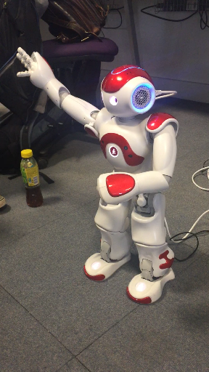

Our Robot during testing.

**Overall description-**

The product is fundamentally a Nao Robot that uses two different but similar programming languages to operate, Choregraphe 2.1.4 and python programming language. The robot uses methods such as voice recognition from user input, logical and mathematical decision, and proximity/motion detectors to carry out its tasks. Our robot performs two major tasks; playing a mathematics based game where it gives the user questions to answer and acting as a calculator where the user says the numbers it wants the calculation to be done on them. Initially, the robot provides a nice introduction then asks the user which of the two actions they would like to do, it uses speech recognition to decipher the answer given. When the first answer is “no” the robot replies with Okay, no problem” and sits down. If it they say maths games; It starts by asking if the supposed user would be interested in playing a maths game. Taking the users response either “yes” or “no”, it goes on to carry out a series of action for “yes” and a mini goodbye message if the user says no before returning back to its ‘resting’ state. The subject the robot teaches is mathematics. It gives the user the option to choose from which section of maths they would like the question to come from. The available sections include; addition, subtraction and multiplication. The questions are generated based on what they child wants. We plan on including a special and optional section, where the user can ask for old questions, these are question that the robot has asked the user(s) previously and they have gotten wrong. It is similar to a memory test and the questions come from the already chosen maths operation. The program generates two random numbers within the range 1-10. After saying the question out to the user, the user is given a long but limited amount of time to answer the question. After an answer is given, the Nao robot will then process the answer after using voice recognition and compare it to the already known answer calculated and stored while the question was being asked. In the case where the user provides the correct answer, the robot will play a happy and/or upbeat tune, let the user know that it was the correct answer, and give a little dance performance. When the user answers incorrectly, a sad tune is played. This is followed by the robot telling the user that the answer is incorrect, and then why- either the number is too high or too low- with an explanation of the question using simple/baby terms. This is open to developments and changes. The second option is the calculator. This uses mostly speech recognition as the user has to say each value and what they want to be done. The robot asks what they would like to do “Choose an operation”, wait for the response, then the user says which out of addition, subtraction and multiplication. After that the user is asked for the two numbers they want the selected option to be carried out on and stores them. The robot takes the values, carries out the operation in an operation box then passes back the answer to the Nao robot to answer. The numbers allowed range from 0-100 and for division it allows up to (5) decimal places.

**Specific requirements-**

Some of our robots primary requirements include:

* Initially Introduce itself and state its purpose
* Understand what the user would like to do
* Provide the appropriate question to the user when they have selected what they would like
* Be able to understand the numbers and action the user wants in task two and give the right answer to the calculation
* Use its speech recognition to check if the users answer is right or wrong
* Give the correct response to their answer
* Give the right reaction to the users answer

In order to do this it must also satisfy its technical requirements in regards to the coding:

* The speech recognition section of the code must be implemented properly
* To complete all the tasks specified on the core block diagram
* The program should be able to be implemented on any robot and work successfully

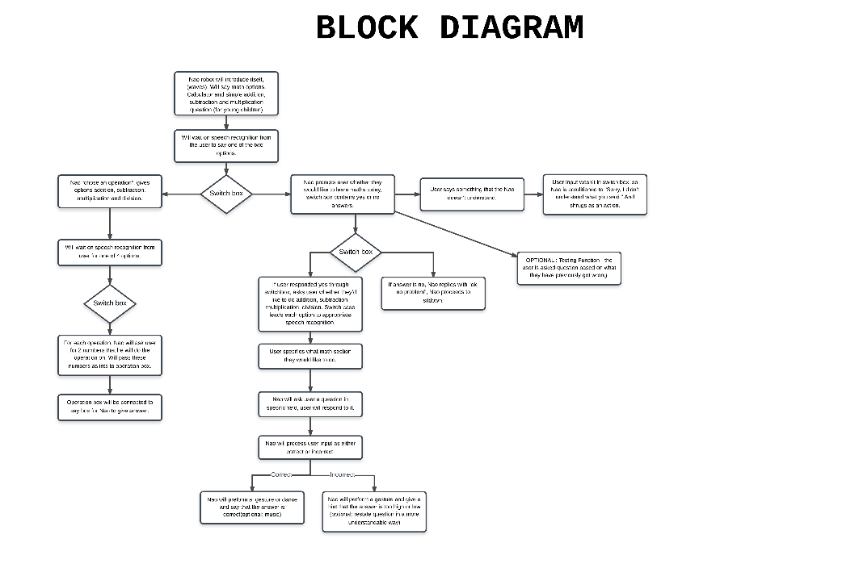

**Supporting information and Appendix-**

This product falls under the category of Entertainment-Education (E-E). Defined approximately as “The process of purposely designing and implementing a message to both entertain and educate, in order to increase the audiences knowledge about an educational issue”[11]

“Whether and to which amount the entertainment–education paradigm is applicable to interactive technology remains still unclear. In theory, one can argue for a general relationship between entertainment and learning that is (a) either linear positive (entertainment as facilitator), (b) linear negative (distraction hypothesis), or (c) inverse u-shaped (moderate enjoyment hypothesis) (see Fig. 26.1).”[12]

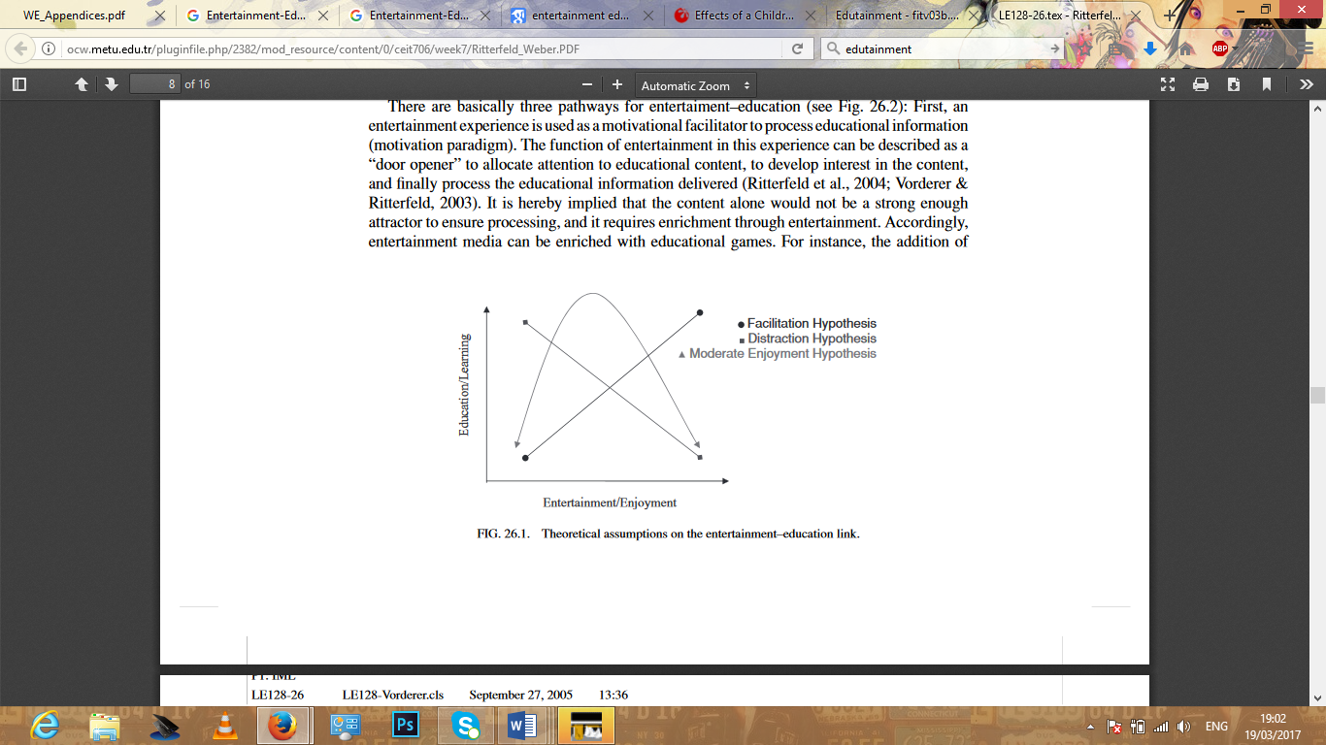

“The nature of learning supported by the use of games could be divided into following three types:

1) Learning as a result of tasks stimulated by the con-tent of the games. The use of games as a stimulus to associated work was mainly restricted to primary schools. But, for example, games with simulations corresponding to real world phenomena can be a starting point for general discussion. Games could be a better stimulus for learning, if teachers were more aware of the importance of games in pupils’ lives, and willing to have children contribute their expertise in these areas to the learning activity.

2) Knowledge developed through the content of the game. Games vary as to the amount of content they contain which is of direct relevance to the school curriculum, but the amount is generally low. Even where the context seems to be relevant to curriculum con-tent, its contribution to the child’s learning may be very peripheral. The best game type seemed to be simulations. Problems in using games include lack of time to play a game, and illogical and too concise content.

3) Skills arising as a result of playing the game. This last type of learning can be subdivided into direct and indirect learning. Skills developed by the games were dependent on pupils’ age but generally they were supposed to develop personal and social skills, cognitive skills (problem solving, deductive reasoning etc.) and Knowledge of content. “ [13]

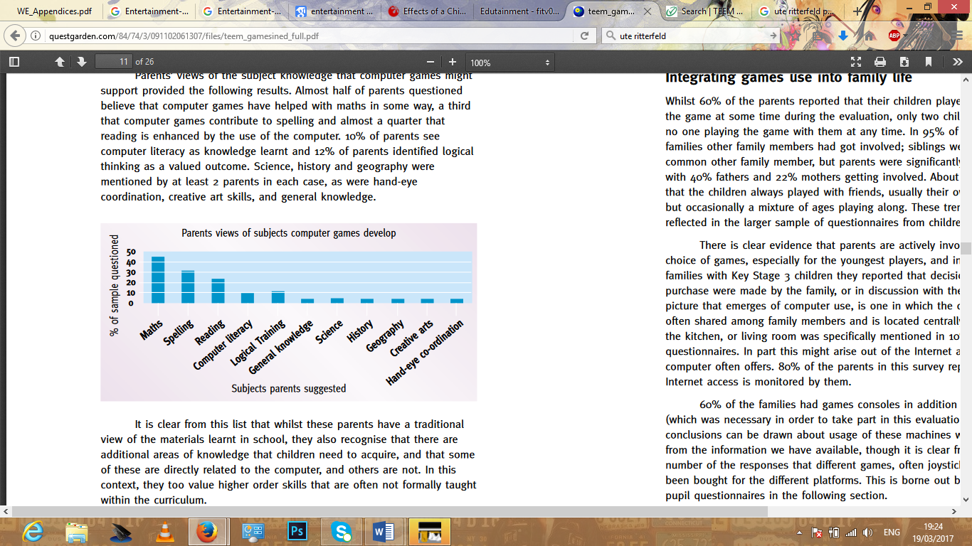

#### This report shows that a mathematics game was the most popular subject amongst those that parents suggested from a research/questionnaire given to parents with children ranged age 5-13.

### 3.II.b The product design (Manik Anadkat)

*What methods did you use to arrive at a set of design solutions?*

We spoke as a team to decide what sort of market we wanted to enter and what competition is already out there.

We made a few options available, one from each person, and then we chose one based on whatever one was most popular with majority of the team.

*How did you make your final choice of design solution?*

We decided to incorporate two ideas together; the idea of a robot that helps young children learn and a calculator. We chose these two as we felt it was something that was not as common and not already on the market. It was also popular amongst the team, which we as a team were more motivated to work on it.

*The Design:*

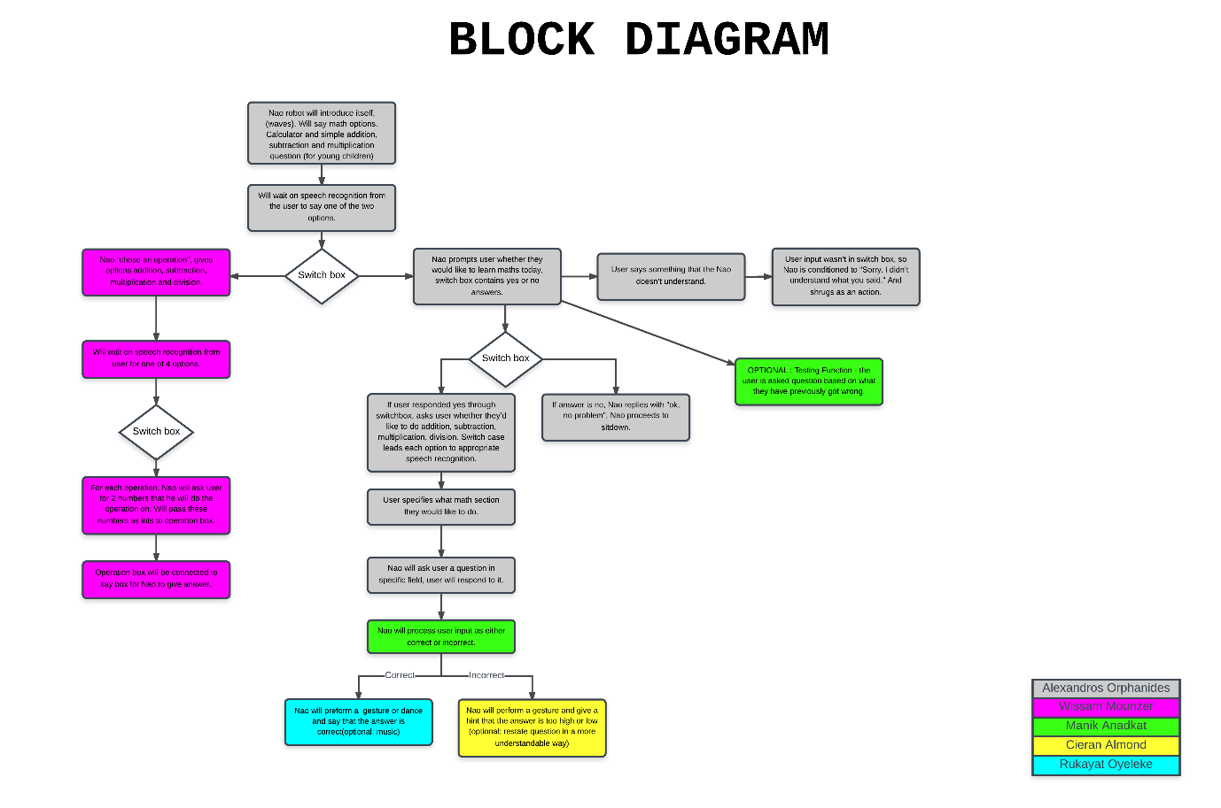

The design is relatively simple, the robot will await input from the user via speech recognition on whether the user would like to be tested on their knowledge or perform a calculation. The user will pick an option and provide more input as required. It is designed to make learning more fun for children; this is achieved by the various actions performed based on the inputs given by the user. An optional ‘testing’ function includes the robot asking the user questions that they have previously gotten incorrect to help the user learn from their mistakes. If a user gives an incorrect answer, the robot will explain the correct answer in terms of objects such as fruit or cars for example. Everything in the above block diagram can be implemented through various python scripts linked together using switch boxes to gain user input and using choreograph to create the robot’s movements.

### 3.II.c The product implementation (Mohamad Mounzer)

Product implementation is when everything single piece of work that has been done to contributed with the programming of the robot is gathered together to make the robot function.

Team B16’s idea was to make an educational entertainment robot which allow young children to learn mathematics in a simple and entertainment way to allow them receive the knowledge of mathematics smoothly and grow some enthusiasm in the them to learn and love mathematics as it is not an easy topic to learn.

To test the robot’s program and functions; implementation had to be done beforehand. The robot had two different options to allow the end user to choose from, one option was to use the robot as a calculator where the end user says two different numbers at a time and then the robot does the calculations. This had to be done using choregraph and taking advantage of the voice recognition for the robot to catch the numbers being said. The other option was to test the end user’s knowledge by asking test questions to see if the user gets them right and when its got right then the robot perform a type of dance to entertain the user; to do so this had to be programmed using some code implementation in python and linking the python code into the choregraph so all function will be in the same place.

If all the part where not put together then the robot wouldn’t be as reliable as it should be, this is because some part would be missing and those part might need to be there to allow other part to function; so If the python code was missing the test session for the user would not work and due to this the dance session wouldn’t not work too because it starts after the python code has end. Some options in the robot are independent of other functions, this would be the calculator option, it is independent, but if it goes missing then the robot will have only one option which the testing of the end user’s knowledge of mathematics.

### 3.II.d The product testing (Alexandros Orphanides)

The testing phases of any project are crucial to the success of the final product. Conducting performance tests in real world conditions, enables a team to identify and resolve any flaws that prevent the correct operation of the software, and were undetected during implementation and simulation based testing.

Our team decided to follow an agile testing approach, rather than testing software only after full implementation. Most team members tested the behaviors they developed separately on the simulation, and made attempts to rectify any issues. However, speech recognition behaviors could not be tested on the simulated robot since the speech recognition module exists on the actual robot, this was a significant limitation of the simulated tests, when considering that speech recognition is vital to the robot functions developed by the team. Following a fair number of simulated tests, it was evident that text-to-speech and movement within our behaviors were working flawlessly. Although, some issues regarding core functions became apparent. The issues were related to the calculator function of the robot, as well as python code within script boxes.

Once implementation was fully completed, we carried out tests on the actual robot, these tests involved all behaviors that we assembled together to form the product. During the first test on the robot, behaviors such as the introduction, speech recognition, and switch cases that were crucial for the control flow of the robot functions worked as intended. However, we encountered a problem with a speech recognition box within the calculator function, that enables the user to select the type of calculation he wishes. Subsequently, another error emerged related to the python script box that generated random math questions, the box did not send a bang signal to the to the say box which followed. Upon completion of the first test, an initial attempt was made to resolve the errors.

 Eventually, we proceeded with the second test run on the robot, the adjustments we previously made solved the problem with the speech recognition of the calculator function, but the python code error resurfaced along with a new bug that affected the calculation behavior of the calculator function. It should also be noted that two behaviors associated with the questions function were not provided by the team member to which they had been allocated, neither for the testing sessions on the robot nor for the product demonstration.

Once the testing phase had concluded, we initiated a debugging session targeted at the errors that arose during the second test on the robot. By the end of the session, the issue related to the python code was solved by implementing the code within the say box and storing random integers as global variables rather than key-value pairs in the memory. Despite our efforts, the calculation error was not addressed in time for the demonstration and was still apparent. Apart from the known issue with the calculator, there was a problem during the demonstration, with the two reaction behaviors that are part of the questions functions, this was inexplicable since they worked fine during testing and when re-run on a different machine a while after. Moreover, the potential risk of the robot falling because of some movement was considered, and precautionary measures were taken during testing to prevent this.

In conclusion, the testing sessions carried out through all stages of product development, were essential for the product to meet the specifications the team had determined. Furthermore, the limited availability of the single robot, is was a negative factor that should be taken into consideration. The two testing sessions with the robot were insufficient, and this was one of the main reasons why the team did not manage to deliver a faultless product.

## 3.III Context

### 3.III.a Legal matters

Legal considerations

Copyright:

Copyrighting your work is the act of protecting your idea/product against people who may decide to use your idea as their own, in addition to rights to publish and sell copies of your idea. “The copyright law time constraints differ from work to work, in the United States, works published between 1922-1978 are protected for 95 years from publication, however work after 1978 copyright lasts the authors lifetime plus 70 years.”[3]

Our product is not an original idea, so we would have to be careful not to infringe on the copyright law that protects the original if it were to be copyright protected. The main thing we would have to be watchful of is non-literary work such as our code, and sound/music recordings that our robot will make when the user gives a correct or wrong answer.

Trademarks:

A Trade mark is used to protect mainly names or logos of your company or product so it is more distinguishable around other competitors, usually a Trademarked logo is immediately compared with the quality/reputation of the company or product. For a trademark to be successfully applied for it must be distinct and not similar to any pre-existing trademarked goods. “Once a trademark has been registered it is indefinite and against the law to reproduce the trademark without the owner’s permission.”[4]

Our product can’t really make use of trademark protection since the main base of our product is centric around the Nao robot, an already trademarked product and name. The only thing that could possibly be Trade Marked is our team name, which would have the robot’s mannerisms and code associated with it rather than the Nao robot itself.

Designs:

Design protection is a very broad term that covers a sub protection rights for other parts of the design process, but generally the term “design protection” refers to the appearance of a product, covering to the extent colours, materials etc. There are two types of design rights, registered and unregistered. “A registered design right provides up to 25 years of protection, whereas an unregistered design right lasts 10 years after it was first sold or 15 after it was created, whichever came first.”[5] Other sub sections that design protection covers are the following:

Copyright: Copyright may exist in designs and will usually protect documents containing the design, paperwork or drawings/concepts. Since these are artistic products they fall under copyright protection.

Design right: Design right belongs solely to the creator, the only acceptation to this being if someone was commissioned to create a design, in which case those rights would belong to the client or party that commissioned the work. The design right stops people copying the shape of the product, but doesn’t cover diagrams or drawings.

Registered right: A registered design covers additional cover over design or copyright rights and gives the creator prolonged protection from copying, the UK being 25 years. A registered design will protect “lines, contours, colours, shapes, texture and materials”.[6] However, there are some constraints for a product to be a registered design, it must be a completely new and original design.

Our product could make use of design protection through the actions our Nao robot will make, since we can’t protect the design of the actual robot due to it not being our product. So when the user gets an answer correct it will perform a thumbs up and when the user gets something wrong it performs a cross with its arms, and though this doesn’t fall under design protection in the literal sense, it is the closest thing that comes to mind since we are not creating our own physical product.

Patents: Patents are used to protector your invention, though a product can only be patented if it’s a completely new, innovative idea that can be manufactured. Aspects the patent will protect range from what things do to how they do it, how they are made and what they are made from. If anyone else uses your invention while you have a patent you have the right to take legal action against that person.

Our product could make use of patent protection, mainly through the use of our Choreograph software and python code, since that would fall under the process used to create the function of our robot.

### 3.III.b Ethical matters

Ethical Considerations:

What intellectual property (IP) is involved here?

Our team name, the code that we have solely created (excluding prefab code that may have been edited slightly), our block diagram of the mannerisms of the robot, the choreograph maps and notes of various ideas that we have progressed through to reach our final idea.

Who owns it?

The person who solely came up with the original concept and developed it, for example Alex and Manik developed code from scratch so IP is theirs. Mohamad choreographed a significant section of the robot by himself, so he owns the IP of that, I wrote down notes and development ideas so the rights to that etc.

This only applies however, if we are not governed by a specific contract or body that is issuing the work and since we are working for the University of Essex under a “charity” non-profit project rights would belong to them instead.

Health and Safety Considerations:

There are a wide range of factors to consider when implementing health and safety considerations to the Nao robot and out team. Here are some of them:

Covering the Nao robots head- There is a fan situated on the Nao robots head, covering it can lead to poor intake, and subsequently overheating of the robot if covered for a prolong period of time. Overheating of the robot may causes damage to internal parts and is a potential fire risk.

Having the robot preform fast movements- This is a safety hazard for both users and the robot; the robot itself can generally only handle slow movements, so having it perform tasks beyond its capability may lead to damaging the robot. In addition, users that are close by to the robot while it preforms these actions may lead to injury.

Operating the Nao robot- Operating the Nao robot should only be done so by a responsible adult, so keep away from children whenever possible as they may damage the robot.

Software development- Developers should be working reasonable hours, not be overworked and maintain a healthy balanced lifestyle.

Having the robot preform actions on different surfaces- Wet or slippery surfaces should be avoided while testing the robot as it can lose balance easily and result in damage to nearby users, or the robot.

What do ALARP and SFAIRP mean?

ALARP or “as low as reasonably predicable” and SFAIRP or “so far as is reasonably practicable” for short is the application of weighing up the risks against an action plus the time and money needed to control it. In the UK this practise is key in workplaces and is the heart of the British health and safety system.

Who is responsible for safety in the UK?

According to [www.hse.gov.uk](http://www.hse.gov.uk) (UK health and safety)[7], under law it is the employers responsibility for the health and safety of its employees, and must do whatever is “reasonably practical” in order to achieve this. It is also the employer’s responsibility to assess the workplace to identify potential risks and consult employees on health and safety issues, whether this be by a representative or union.

### 3.III.c Sustainability

What aspects of sustainability are relevant to your product?

Questions of sustainability for the Nao robot and our product are: scalability of our product into the future, code sustainability and energy considerations.

If possible, we would be following the IET rules of conduct [8] allowing “all reasonable steps to avoid waste of natural resources, damage to the environment, and damage or destruction of man-made products.” With additional considerations to public health, safety and environment.

### 3.III.d Health & safety matters

Since we are not producing a physical product, more just developing code to produce a teaching robot, our product will not cause damage to the environment or waste materials unless the production of the physical Nao robot is a source of this. In addition, since our code is very scalable, there will be hardly any waste since we can take the overall shell of what we have and just make it more difficult for older audiences if need be, so there will be minimal waste of electricity which would be the resource we are using the most.

Can you estimate energy costs for your product?

Computer usage averages 2 hours per week which equates to 105 watts x 2 hours x 6 members = 210 x 6 = 1,260 watt-hours. Lets say the project spans over the course of a year, so there are 1,260 x 52 weeks/year = 65,520 watt-hours or 65.5 kWh. If the average cost of a kWh in the UK is 12 pence then average costs of running the computers for the entire team equates to around £780.00.

The Nao robot runs on a 2600mAh battery which lasts around a year and cost around £50.00 to replace.

How might you look at ways to reduce the carbon footprint of your product?

The only way you can reduce the carbon footprint of the things specified above is with more efficient, less power hungry computers, though the lower power consumption computers tend to be slower for the user so they may spend longer on the computer.

# Chapter 4: Project Management (2140 words) (Ceiran Almond)

## 4.I An introduction to Project Management

What is a project and what is project management?

By definition, a project is a “planned set of interrelated tasks to be executed over a fixed period and within certain cost and other limitations” [9]

During this time, teams use their collective skills and tools to meet the set requirements, and are defined in a set of parameters:

1. Integration
2. Scope- An agreement on what needs to be done and developing the proposal into a plan, usually transcribed in a document for later reference.
3. Time- When does this product have to launch by.
4. Cost- Cost of labour, materials, time, renting space etc.
5. Quality- Deciding if the project will be premium or just average consumer level.
6. Procurement
7. Human resources
8. Communication
9. Risk management
10. Stakeholder management

Project characteristics, risks, processes

A project is a mission to create a unique product or service; achieving a particular aim you set out to do. Though once a project has been completed, that is it, you can potentially move onto another project or do something else entirely, point being that it’s a temporary thing; there is a defined beginning and end. A project will also always have a definite time frame, slowly incrementing over this timeframe.

Risks are always present in projects, and its almost impossible to take into consideration every single problem a project may present. Some example risks you may ask yourself are:

“There is a risk that the Nao interface wont be compatible with different coding languages”

“There is a risk conditions for testing the Nao robot aren’t suitable”

“There is a risk the client may introduce new requirements relating to… of the project”

A key thing to note is the difference between “risk” and “issues”, issues for the most part have a potential fix, whereas with risks other elements out of your control may be the defining problem.

The process of a project is broken down from beginning to end and divided up into a set of parameters:

Scope- Scoping out the market, identifying goals, specifications and getting approval to plan.

Planning- Deciding what needs to be done and when for, usually with a set budget. These will be implemented into a project plan.

Launching- Creating a team and establishing roles that fits the individuals skill sets.

Monitoring- Keeping tas on time, addressing issues with the team and keeping everyone informed with changes happening to the project.

Closing- Comparing what was achieved with the product/service and comparing that to initial goals and subsequently launching the product.

What are reasons for having planning?

Having a degree of planning is only the sensible thing to do while doing anything; it defines an objective, and with that reduces chaos around organisation.

When you define a plan to a team, there are set goals to achieve and so everyone has something to work towards and be proactive around. This reduces the probability of delays, going over budget and keeps teams on task.

Therefore, general reasons for having planning would be to keep everything in check and on time, from team members to money and time.

Project management methodologies

As mentioned in part 3 of the team report, there are 3 main management methodologies that have their own uses, depending on how long the project is or what you want to achieve. They areÖ

Waterfall- Linear, everything has to follow one path (the one we used this project)

Extreme- Software methodology that is similar to agile; the project is constantly changing depending on the clients needs.

Agile- Adaptive, things are subject to change and the methodology accounts for that.

Project management tools (Gantt charts)

After you create a basic generic outline of what a project consist of, you can use a Gantt chart to think through all the tasks of your project and adjust accordingly. From this process you’ll be able to decide who to allocate to certain tasks, the time it will take, and any planning necessary as a contingency plan for problems you may encounter.

Now you will have visible schedule you can refer to at any point during the project, keeping the team informed of progress and tasks that need completing.

Monitoring (Reports, milestones, costs/expenditures, problem escalation, risks)

Monitoring is the process of evaluating the project during certain intervals to ensure everything is running smoothly through gathering data. An example of data being checked would be to ensure status quo, costs, analysis of deviations/problems and risks.

This data can be used in a milestone list, including progress/deviations with columns such as “achieved y/n”, “forecast date” and “reason of delay” for example.

An example of a “report” in a sense would be the team assessment page we filled out evaluating performance of team members.

Failing projects (prevention, intervention, revising)

There are a multitude of reasons a project can fail, especially if you’re in a team; some examples that come to mind immediately from our own team experiences are team member conflicts, overcomplicated ideas that lead to poor productivity and changing the final idea multiple times.

Ways to prevent examples previously mentioned would to have weekly talk/review periods for team members to explain their issues or ideas or using the Gantt chart to factor in potential issues such as this.

Speaking from personal experience, there was intervention to resolve these issues with our GA and the Dr where we identified the root cause (over complication of the idea) and changed it appropriately.

[3] Project revising is “if a project is failing it may be able to be rescued through a revision of the plan. It’s crucial to have client engagement, to consider stopping altogether although there may be real costs to failure”. upon reflection it is apparent that our team was on track to become a failed project, though through using prevention, intervention and revising our idea have managed to persevere though.

## 4.II Project Management Report

### 4.II.a A description of the Gantt chart[1]

Quick Gantt chart description

Our Gantt chart has been adapted to display project issues we have encountered; we found it hard to stick to a certain idea, and when we did we decided that idea was too hard to bring to actuality. This is seen under brainstorm new ideas, where we took a 3 day period to discuss among ourselves and Lab assistant about the best course of action proceeding forward. We decided to keep elements of our original idea, salvaging out choreograph and adding to it, this is represented with “implement new ideas into choreograph and code”. Finally we made the last refining touches to the idea, adding some optional parts that we would implement if the core idea was complete. This required a little bit of extra research since it was more technical than our other stuff, so this was accounted for in “researched choreograph elements needed...”. With everyone happy with the project idea we finalised our block diagram and designated writing tasks the same day. The only discrepancy in our Gantt chart is the testing; testing was pushed back to 08/03/17 due to the amount of booked slots for the robot, we however booked 2 sessions for that day to make up for lost time; one in the morning and one in the afternoon. Essentially the afternoon one had to act as our “final testing” as it was the last session, so after testing in the morning, we used the time to debug as much as possible before the test session in the afternoon. “Minor improvements/adding extra features” was supposed to be tested but was not complete by the deadline, so went untested. Looking back we left a lot to the last minute and think we should have been more proactive in developing our first idea (even though we changed it in future) earlier on in the development process, around November, December time.

Rukayat Oyeleke:

The project was managed efficiently but our final program could have been better if we had all the parts submitted earlier. However, the team report was on track throughout and came out acceptable with almost everyone doing their tasks properly and on time.

Alexandrosa Orphanides:

In my genuine opinion, the team could have been more organised, and should have come up with a better strategy on how to tackle the tasks at hand. To ensure that future projects are more successful, the team should lay out a plan that includes deadlines for each task. This plan should also consider time-management, and there should be some sort of supervision within the team, to guarantee that task deadlines are met.

Mohamad Mounzer:

The team manager was really friendly and putt so much effort into the team work to make sure that every task has been met although there were a lack of communication at the beginning when the team first met but the project manager was able to still organise some time slots for the team meeting so that team members will not have to experience a lack of communication. Overall the team management was efficient and helped the team meet requirements and finish tasks on time.

Manik Anadkat:

The project was managed successfully, however I think the final product would have been even better had we been allocated parts both slightly earlier than we did and based on our previous knowledge. That said, team management was very efficient when it came to completing the team report.

### 4.II.b An evaluation of the project management

My personal experience with project management:

Having never done management in a team before, this was an entirely new experience to me. I volunteered myself for the role because I am good at timekeeping and taking down notes. When first receiving the draft for the project people made it clear what roles they were good at and I allocated those roles accordingly, which everyone was fine with. I feel like I also applied this technique when allocating roles for who does what part of chapter 3. The easiest part for me was attending every lab and recording the register and taking notes on what happened on the session, and telling people what needs to be done and by when. I had issues with telling people that were not doing the work, showing up or doing the work late that they need to step up slightly; I personally felt that there wasn’t any point mentioning anything about people that didn’t turn up as long as the work was covered for their absence. This is because I felt that even though I mentioned it to them that they needed to turn up to lab sessions, they would for one session but not the next and it would become a waste of time. In addition, maintaining and changing the Gantt chart was a nuisance to me because I felt that we didn’t really utilise the timescales it provided, and so was of little relevance. I don’t blame anyone for this as there was other work and modules to be done, and can see how it would be a really good tool if people were solely working on 1 project. I made sure to post team roles on the team forum and in the Facebook messenger group chat and believe that everyone knew the role they were working on.

What I have learned from project management and what I think I would change next time being a project manager:

I have learned that during project management you need to have really good structure to a project as this gives you a really good start on progressing quickly and in forward momentum as a team. There is no use one person being ahead of the other if the person that has finished requires components that the other people are working on (this was experienced in the team) as it just results in the finished person becoming frustrated if they have nothing to work on.

I have realised this mistake now, and though it’s hard to allocate roles that the person may not necessarily know how to do, there should be an allocated time frame where you set them a task to help them learn that role to more detail. I also feel like I should have been more specific with members of the team that didn’t attend lab sessions, as they would occasionally come to me asking what they should do.

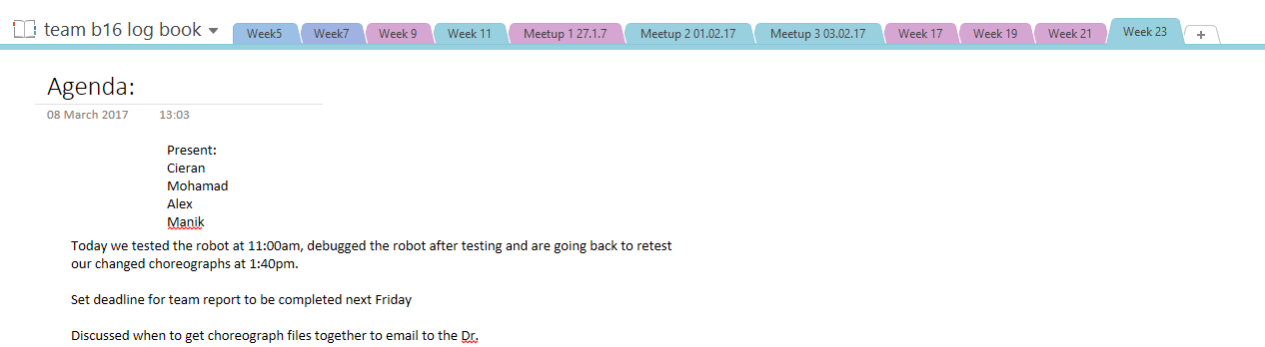We also had an incident of our team becoming very frustrated with each other, where there was no sense of direction or agreement on our first agreed upon idea; some members felt that what we had set ourselves was too complex after working on the idea a lot, others felt that it was fine, though they hadn’t worked on the idea as much. This disagreement led to us having to get outside help through Lab assistants and the Dr. After everyone had discussed there issues we came to a compromise that everyone was happy with, however as a project manager I felt like I should have taken the initiative to speak with the unhappy members and change the project accordingly so outside help was not needed.

# Chapter 5: Conclusions (488 words) (Alexandros Orphanides, Ceiran Almond, Rukayat Oyeleke, Mohamad Mounzer, Manik Anadkat)

During the first term, the team faced a few problems, the team was rather dysfunctional and not very productive. Furthermore, although we did not encounter many attendance related problems, there was a lack of effort and motivation from some team members. There was a period of uncertainty within the team, where team members had no clear task allocations and the team had not yet created a specification document or come up with a solid design idea. However, as time progressed we managed to regroup and worked cooperatively to overcome these obstacles. By the end of the term we worked effectively as a team and made significant progress in regards to product development. Alex Orphanides)

The project management during the early stages of the project was lacking which was probably a contributing factor of team dysfunctionality further down the line. However, this was rectified after everyone was sat down to discuss their issues. We salvaged parts of our original idea which had little direction and organisation to it and added our new universally agreed-upon idea to it, the Gantt chart was adjusted accordingly for this. Because we were behind due to the changes, we had to catch up with out of lab meetings, in total scheduling 3. These were helpful for catching up and allowed us to have an almost functioning robot by the end. (Ceiran Almond)

The implementation of the product was important for the testing stage to start, therefore, it had to be done before starting to test the product. While the team was implementing the program, and bringing all the separate pieces of work all together, the team experienced a little bit of difficulty to link different python codes and choregraph functions together. The stage where the team experienced difficulties is where it came to linking the python code into the choregraph and making the program function in the virtual program before taking the robot for testing. (Mohamad Mounzer)

The project was managed efficiently overall but our final program could have been better if we had all the parts submitted earlier to ensure they were working properly. However, our team report was generally on track throughout and came out acceptable with almost everyone doing their allocated tasks properly and on time. In order to avoid some issues, next time we should have made stricter rules for task assignment, alternative/back-up plans for when a member fails to do his/her task and by working faster while resolving team issues. (Rukayat Oyeleke)

I have tried my best to attend all scheduled meetings, with a few exceptions, for example when I was unwell. Whenever I missed a meeting I would always find out what I have missed and catch up to ensure I don’t fall behind. Throughout the process, I worked on the sections allocated to me, came up with the original idea of a robot that teaches maths and helped with the design/re-design of the block diagram. (Manik Anadkat)

# Appendix A (Alexandros Orphanides)

## A. Python Code

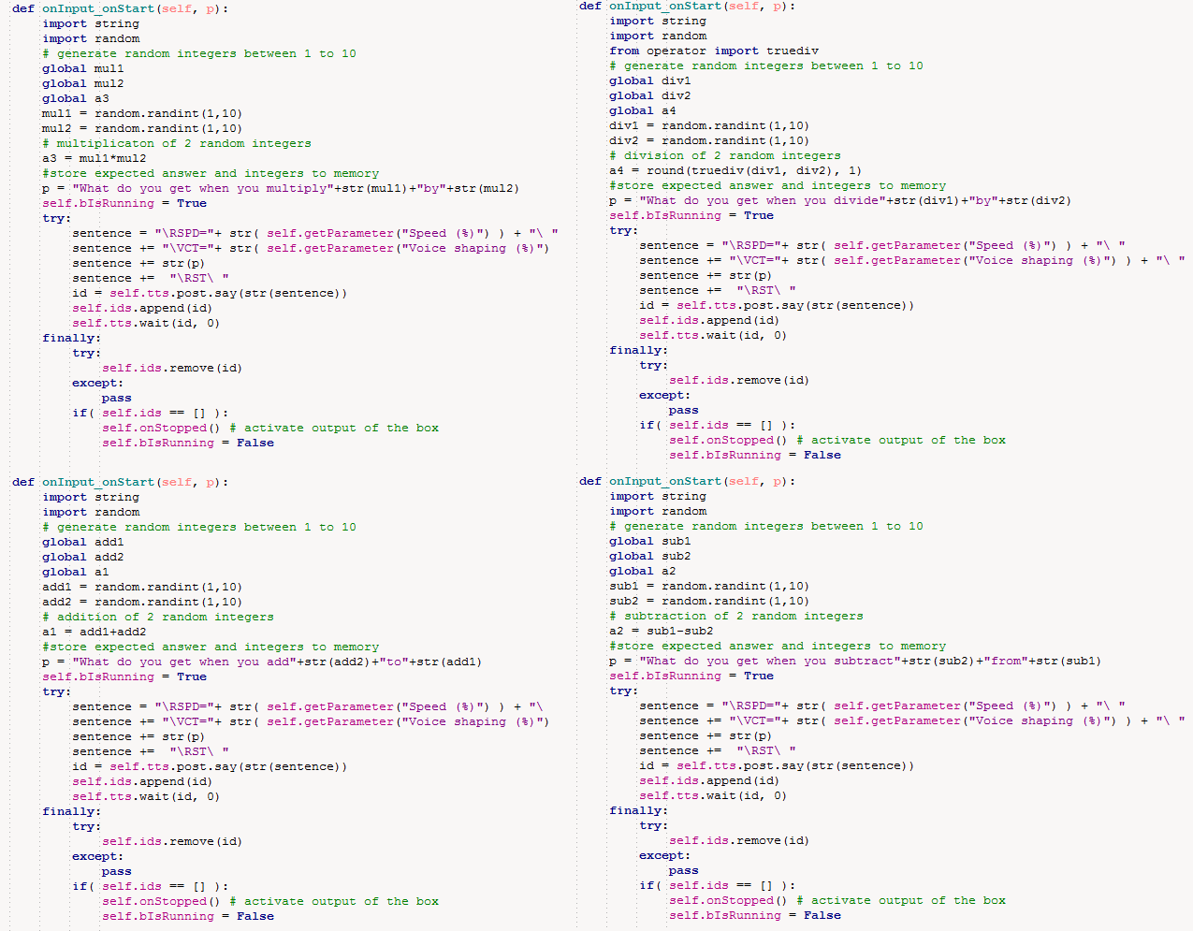

## B Team effort summary table (Mohamad Mounzer)

|  |  |  |  |  |  |  |  |  |  |  |  |
| --- | --- | --- | --- | --- | --- | --- | --- | --- | --- | --- | --- |
|  |  | **Meeting Attendance** | **Number of references added to the database** | **Number of précis added to the database** | **PowerPoint presentation given to team in week 19** | **Agendas in team logbook** | **Minutes in team logbook** | **Discussions added to the Team forum[2]** | **Product Development** | **Report Writing** |  |
| **Team Member** | **Role** | 0-10 | Rank order[3] | Rank order | 0 or 10 | 0-10 | 0-10 | Rank order | Rank order[4] | Rank order3 | TOTAL |
| Mohamad Mounzer | **Leader** | 8 | 0 | 0 | 10 |  |  | 5 | 5 | 6 | 34 |
| *Cieran Almond* | **Project Manager** | 10 | 0 | 0 | 10 | 10 | 7 | 10 | 5 | 6 | 58 |
| Rukayat oyeleke | **Specialist** | 6 | 0 | 0 | 10 |  |  | 3 | 4 | 5 | 28 |
| Alex Orphanides | **Specialist** | 9 | 6 | 6 | 10 |  |  | 1 | 6 | 4 | 42 |
| Manik Anadkat | **Specialist** | 8 | 0 | 0 | 10 |  |  | 3 | 4 | 5 | 30 |

## C Project management Gantt chart (Cieran Almond)

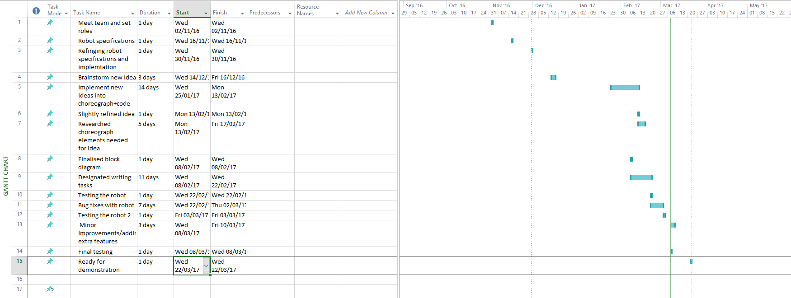

**Bibliography:**

[1] char.txa.cornell.edu\language\creative.htm

[2] www.mindtools.com\pages\article\newTMC_00.htm

[3] fairuse.standord.edu\overview\faqs\copyright-basics\

[4] moodle.essex.ac.uk\pluginfule.php\56408\mod_book\chapter\6324\Student%20Handout%20IP%20information.pdf

[5] en.wikipedia.org\wiki\Design_right

[6] moodle.essex.ac.uk\pluginfule.php\56408\mod_book\chapter\6324\Student%20Handout%20IP%20information.pdf

[7] <http://www.hse.gov.uk/workers/employers.htm>

[8] Slides from moodle - https://moodle.essex.ac.uk/pluginfile.php/616927/mod_resource/content/0/Ce101Team%20reports.pdf

[9] <http://www.businessdictionary.com/definition/project.html>

[10] <https://moodle.essex.ac.uk/mod/book/view.php?id=307507&chapterid=6317>

[11] Singhal, A. and Rogers, E. (2012). *Entertainment-Education*. 1st ed. St. Louis: Taylor and Francis.

[12] Vorderer, P. and Bryant, J. (n.d.). *Playing video games*. 1st ed.

[13] Edutainment: From Television and Computers to Digital Television -Sari Walldén, Anne Soronen

1. Gantt chart in Appendix C
2. Only include top-level posts, not replies.
3. For example for a team of 6 give 6 to the person with the highest number.
4. You can give the same rank order to more than one team member so if all have contributed equally then for a team of 6 score 6 for all.